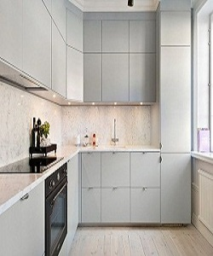

Kitchen Furniture

$258.16

Availability: In stock

Description

The material is a strong, tightly-wrapped and heat-sealed, easy-to-care for and impervious to stains. The smooth-surfaced doors are custom made to your kitchen project, and are available in a range of sheen levels, colors and wood grain textures.